Design Phase of the Joint Project around the Senegal Mauritanian Aquifer Basin led by the Regional Working Group

Deliverable number 3:

Report on the extent and recharge of the SMAB

DOCUMENT STATUS: APPROVED BY THE REGIONAL WORKING GROUP

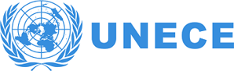  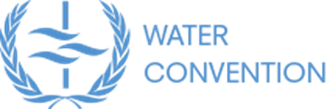 | 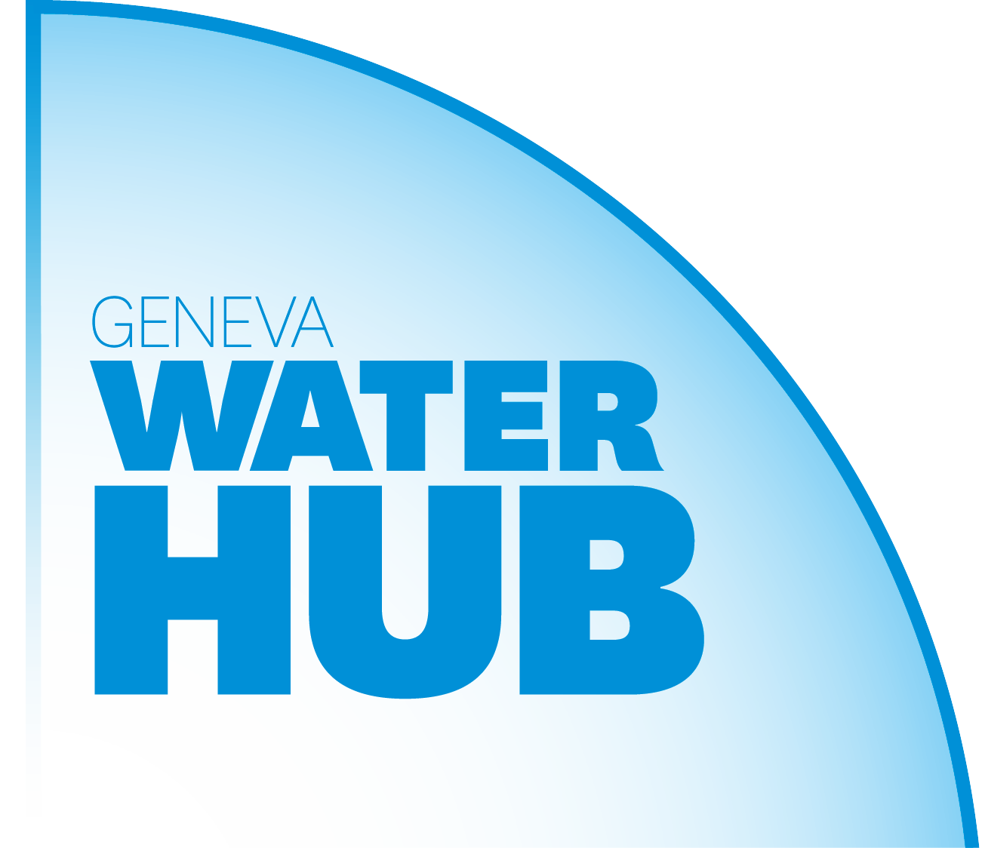 | 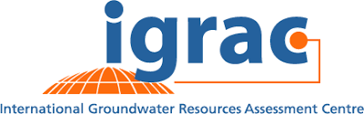
With the financial support of
 | 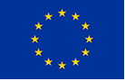 | 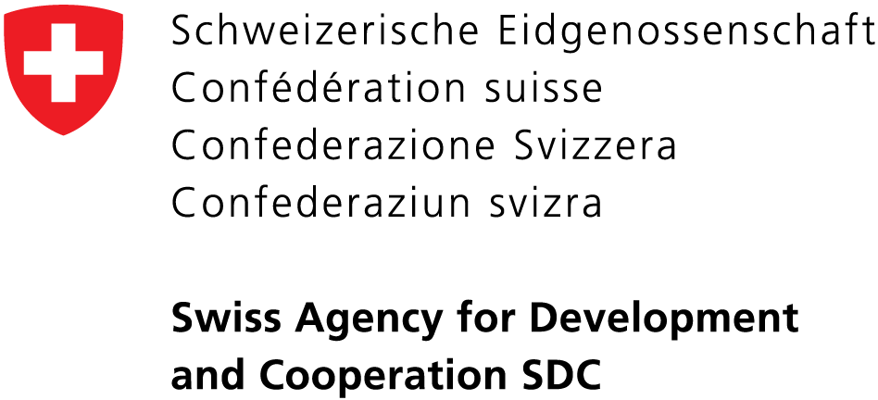

Table of Contents
1 Introduction 3
1.1 Background 3
1.2 General Objective 3
2 Groundwater in the SMAB 3
2.1 Groundwater, the Main Source of Water in the SMAB 3
2.2 The Role of the TBOs in Water Resource Management 4
3 SMAB Features 4
3.1 Extent of the the SMAB 4
3.2 Major aquifer systems 7
3.2.1 The superficial aquifer system 7
3.2.2 The semi-deep aquifer system 7
3.2.3 The deep aquifer system 7
3.3 Potential and recharge of the SAMB aquifers 8
3.4 Interaction with surface water under TBO jurisdiction 9
4 Issues and Challenges in Managing SMAB Aquifers 10
4.1 Water Resources Availability in Quantity and Quality 10
4.1.1 Water availability, a major challenge 10
4.1.2 Improving the knowledge base and water resource monitoring 10
4.1.3 Water quality 11
4.2 Governance and Sustainable Management Financing 11
4.2.1 Concerted management of transboundary water resources 11
4.2.2 Sustainable management financing 12
4.3 Cooperation, Peace and Security in SMAB Countries 12
5 Services Provided by SMAB Aquifers 13
5.1 Domestic, Agricultural, Industrial & Tourism Extractions 13
5.1.1 Domestic extraction 13
5.1.2 Extraction for agriculture and grazing 14
5.1.3 Industry and service 14
5.2 Water Course and River Ecosystem Services 14
6 Studies Carried Out in the SMAB and Knowledge Gained 15

Introduction

Background
The Senegalo-Mauritanian Aquifer Basin (SMAB) States, which include Gambia, Guinea Bissau, Mauritania and Senegal, have been engaged in dialogue aimed at implementing transboundary cooperation with regard to this shared water resource. This dialogue is in close collaboration with the Transboundary Basin Organizations (TBO), that is, the Gambia River Basin Development Organization (OMVG) and Senegal River Basin Development Organization (OMVS). This dialogue has also received support from the Geneva Water Hub (GWH) and the Secretariat to the Convention on the Protection and Use of Transboundary Water Courses and International Lakes (hereafter, the Water Convention), under aegis of the United Nations Economic Commission for Europe (UNECE).

General Objective
Regional dialogue on the SMAB aims to establish transboundary cooperation with regard to this shared groundwater resource. It is carried out by the SMAB States, that is, Gambia, Guinea Bissau, Mauritania and Senegal, in close collaboration with the Transboundary Basin Organizations (TBO), that is, the Gambia River Basin Development Organization (OMVG) and Senegal River Basin Development Organization (OMVS).
The objective of this dialogue is to produce a project document and plan of action for the implementation of a long-term mechanism for joint management of the SMAB. In order to achieve this, reports and diagnostics (five in all) are the deliverables making it possible to support strategic choices and the project. Among them, this third report aims to provide information on the real extent of the SMAB and its recharge, including mapping, in order to serve as a foundation for decision-making regarding the need for the TBOs to provide general management to complement the SMAB’s surface water management.

Groundwater in the SMAB

Groundwater, the Main Source of Water in the SMAB
Groundwater plays a major role in Africa’s socioeconomic development. According to UNECA (2000), 75 per cent of Africa’s population depends on groundwater to meet its basic water supply needs. Groundwater is widely used in Africa, which is home to over 70 transboundary aquifer systems (IGRAC 2015).
The SMAB countries, that is, Gambia, Guinea Bissau, Mauritania, and Senegal, depend on groundwater resources to meet 80 per cent of their population’s domestic needs (DGPRE, 2011; NIRAS, 2015). In rural zones, groundwater is often the only source available to meet water supply needs, and due to demographic pressure, climate variation and economic changes, there is a risk of a substantial increase in the use of groundwater, notably for irrigated agriculture. This is already the case in urban centres, such as the Dakar region, where 60 per cent of the water supply is provided by groundwater from the SMAB aquifer system.
Additionally, the SMAB countries have adopted the 2030 Sustainable Development Agenda, with international commitments aimed at, inter alia, “achieving universal and equitable access to safe and affordable drinking water for all” (SDG 6.1), as well as fighting poverty, ensuring food security and preserving the environment. As part of this framework, groundwater will be in high demand. In order to preserve it, transboundary cooperation is more necessary than ever in order to improve the knowledge base and institutional mechanism to promote the implementation of appropriate shared (ground) water resources management. The TBOs play an essential role in this approach.

The Role of the TBOs in Water Resource Management
The Gambia River Basin Development Organization (OMVG) and the Senegal River Basin Development Organization (OMVS) have similar missions, that is, developing their respective basins, economic development, improving the living conditions of neighbouring communities and fighting poverty in a context of sustainable development. The OMVG manages three drainage basins, the Gambia, Kayanga-Geba and Koliba-Corubal, while the OMVS manages the Senegal River Basin. Both have a political mandate covering a large portion of the SMAB.
Both river basin organizations also have lengthy experience with the transboundary management of surface water. From this perspective, they provide a “ready-to-use” platform to address mutually beneficial groundwater management and their strategic use for adaptation to climate change, as well as the socioeconomic development of member states’ populations. This leadership will become more beneficial, as they will be able to promote better understanding and appreciation of the exact dynamics of the interaction between groundwater and river systems (integration of groundwater in the broader management of water resources in general), as well as the groundwater system’s links and dependencies (base flow, tributary ecosystems and aquifer recharge).
During its sixth session in Brazzaville (Congo) from 30 to 31 May 2007, the African Ministers Council on Water (AMCOW) spoke in its resolution of the need to promote “the institutionalization of groundwater management by river basin organizations”.
Additionally, the final communique from the Seventh Africa Water Week (Libreville, 29 October – 2 November 2018) “urges AMCOW to set up an African Groundwater knowledge sharing and policy coordination desk… for the promotion and increased understanding and use of groundwater resources in addressing water security in Africa”.
Both transboundary river basin organizations are members AMCOW’s “technical arm”, the African Networks of River Basin Organisations (ANBO), which has long urged that the development opportunities provided by transboundary aquifers be considered and included in the mission of African River Basin Organizations. It is also worth noting that in its Article 17, the OMVS Water Charter stipulates “mapping aquifer recharge zones, in order to take inventory and delineate accretion and capture zones and understand the interaction between surface water and groundwater.”

SMAB Features

Extent of the the SMAB
The Senegalo-Mauritanian Aquifer Basin stretches over about 1,300 km, between Cap Blanc in Mauritania to the north, and Cap Roxo in Guinea Bissau to the south. It spans 550 km at the latitude of Dakar, bordered by the Atlantic Ocean to the west, the Precambrian base of the Reguibat RIse to the north, and to the metamorphic rocks of the Mauritanides Belt to the east and southeast. To the south, the basin lies on the Paleozoic sediments of the Bove Basin (Figure 1).
Figure 1: Geological map of the Senegalo-Mauritanian sedimentary basin

The SMAB covers an area of 331,450 km2, which include a large portion of the territories of the countries that share it: 100 per cent of Gambia, 37 per cent of Guinea Bissau, 14 per cent of Mauritania and 84 per cent of Senegal. The population is estimated at 11,930,000 inhabitants by Altchenko & Villholth (2013).
The basins of both TBOs overlap the SMAB, with the OMVS basin in the centre and that of the OMVG further to the south. They share nearly 50 per cent of their surface area with the SMAB, at 32 per cent and 18 per cent respectively (Figure 2).
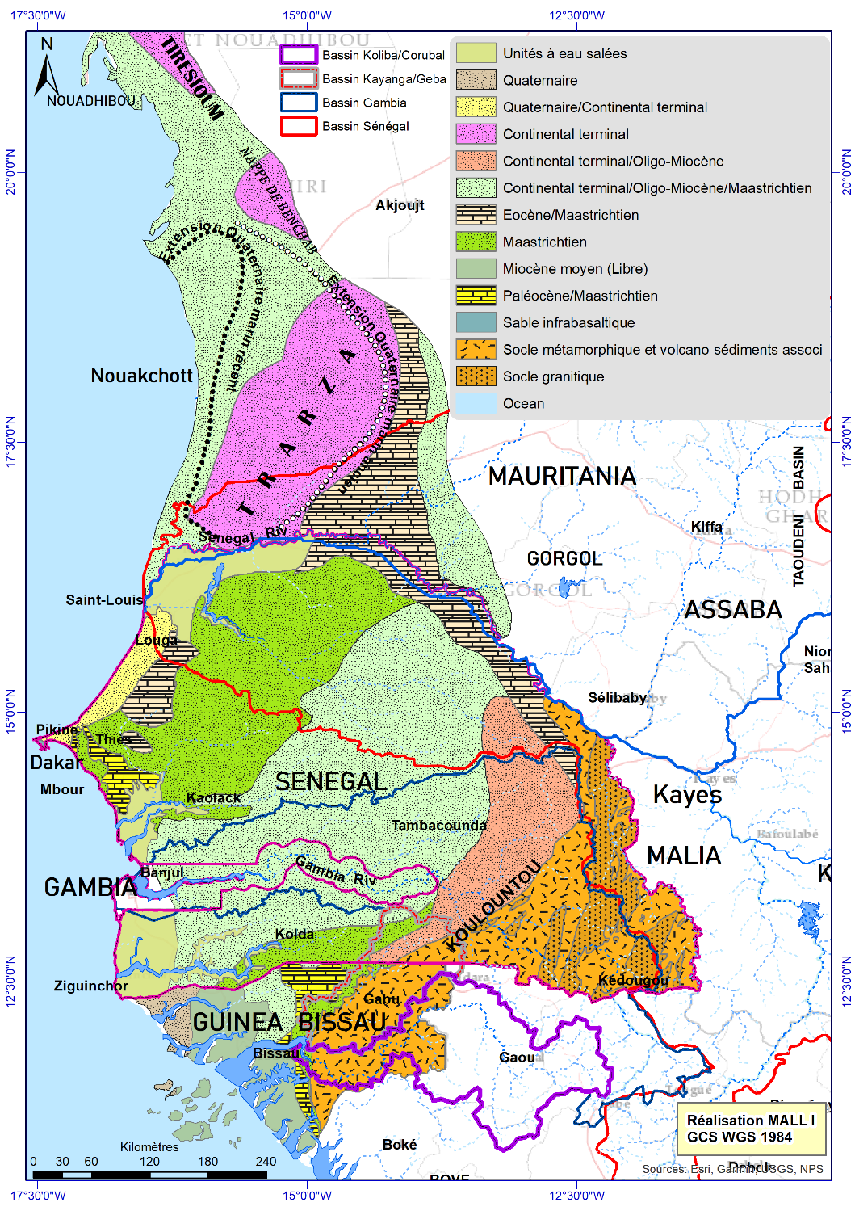
Figure 2: Hydrogeological map of the SMAB

Major aquifer systems
The SMAB includes several overlapping aquifers between the Senonian (Upper Cretaceous) and Quaternary. They can be grouped into three major aquifer systems, which can generally be found in all aquifer basins.

The superficial aquifer system
In Senegal, this system includes the coastal sand aquifers of the Quaternary between Dakar and Saint Louis, and the alluvial formations of the Senegal River Valley. The thickness of these formations varies widely, from a few metres to several dozen metres. This system also includes the Oligo-Miocene aquifers and those of the Continental Terminal, which are generally hydraulically linked and present similar geological facies. These aquifers are found in the south, east and northeast of the country, extending into Gambia and Guinea Bissau at the southernmost end of the system.
In Gambia, this system is the “Shallow Sand Aquifer (SSA)”, which is of Mio-Pliocene geological age, mainly made of unconsolidated, medium to coarse sand grain and found at 15 to 120 metres depth below the ground level. It is further partitioned into the Upper Phreatic Aquifer and a Lower Semi-Confined Aquifer, separated by a thin clayey-silt aquitard of 15-30 m thickness Currently, the Gambia abstracts from this aquifer through traditional hand dug wells tapping from the upper phreatic aquifer while boreholes are drilled deeper into the lower semi-confined aquifer (NIRVAS, 2013). This aquifer system is the main source of drinking water for the capital city of Banjul. The same configuration can be found in Guinea Bissau, where the quaternary Miocene horizons contain groundwater captured between 2 and 20 metres. Oligocene aquifer formations are also present, situated between 80 and 100 metres on the Island of Bubaque, where the groundwater is brackish. In Guinea Bissau, these superficial horizons serve as the main water reservoir for rural populations, through traditional wells or hand pumps.
The superficial aquifer system is also present further north in Mauritania, and more specifically in the detrital sediments of the Continental Terminal (measuring 60-150 metres thick), which contains the Trarza aquifer. This is the site of the Idini drilling fields, and a strategic resource that supplies the city of Nouakchott. Further north, the freshwater aquifers in Bennichab, which supply the economic capital of Nouadhibou, and in Boulenoir are also major water resources for Mauritania. Static levels of these aquifers vary between 21 to 39 metres. This system also contains the Amechtil Eocene limestone aquifer, captured by boreholes no deeper than 100 metres, with a flow of up to 10 to 30 m³/h. The same is true of the Brakna aquifer, which is made of Middle Eocene sands, and located along the sedimentary basin in eastern Mauritania and captured by pumps at 20-30 metres deep.

The semi-deep aquifer system
In Senegal, this system includes Eocene and Paleocene marly limestone. These formations only present interesting hydrogeological features in parts that have undergone a karstification phenomenon, for example, in the Diass horst zone, where the limestone formations rest on the Maastrichtian formations. The two aquifers are hydraulically linked, and together contain large quantities of water that supply the Dakar region.
In other countries, the semi-deep Paleo-Eocene limestone formations in the SMAB do not appear to present interesting hydrogeological features.

The deep aquifer system
This system includes the so-called Maastrichtian aquifer, which extends over the entire sedimentary Senegalo-Mauritanian Basin, at a depth of 25-500 metres. The aquifer has shown high to very high productivity in the central, north and south basin, and average productivity in the east and west. It is captured by boreholes (over 830 boreholes are currently listed) in Senegal, according to the DGPRE. For example, the drilling fields are built in the Diass horst zone, where the aquifer rises to the surface, and capture the Maastrichtian groundwater or that of the Paleocene aquifer connected to it. Together, they supply a large portion of Dakar’s water.
In Gambia, this is known as the ‟Deep Sandstone Aquifer (DSA)”, which mainly includes poorly consolidated sand and sandstone buried at 250 to 450 metres deep. This aquifer is largely undeveloped with only three exploratory boreholes in the East, Central and Western part of the Gambia, and thus generally uses the superficial aquifer system groundwater to satisfy its drinking water needs. In Mauritania as well, the Maastrichtian aquifer’s hydrogeological potential is untapped, as the water quality is poor (due to high salinity) and would not be productive (due to low hydraulic conductivity due to the higher levels of clay).
In Guinea Bissau, however, which forms the southern border of the SMAB, the Maastrichtian aquifer system plays a major role, with a thickness reaching over 500 metres. It is homogenous and powerful, comprised of detrital formations, and Guinea Bissau’s most productive aquifer. It extends over several regions including that of Bissau. To the east, the aquifer rises to the surface, on the edge of the Paleozoic bedrock. This is Bissau’s main water source, and in the capital region, water is captured by both public and private boreholes at 200 to 250 metres deep, with flows of over 100 m³/h.

Potential and recharge of the SAMB aquifers
In Senegal, the Maastrichtian aquifer represents the country’s main source of groundwater supply. The Maastrichtian aquifer layer in Senegal is a major reservoir, with reserves estimated at between 300 and 400 billion m³, and accounts for 40 per cent of Senegal’s sedimentary basin aquifer collections. The situation is very similar in Guinea Bissau, where the deep aquifer is the main source of water in the Bissau region. Here, reserves are still unknown, due to a lack of updated data and information (Joseph and Lasry, 2012). The situation is somewhat different in Mauritania and Gambia, where the deep aquifer is not in demand. According to literature, Gambia meets all of its drinking water needs using water from its superficial aquifer system. In Mauritania, the superficial aquifer system reserve containing the Trarza, Boulenoir and Benichab aquifers is estimated at between 50 and 120 billion m³.

Table 1: Estimated aquifer systems reserves in SMAB countries (billions m³)
Country | Superficial system | Semi-deep system | Deep system
Gambia | 36 | - | -
Guinea Bissau | - | - | -
Mauritania | 50 - 120 | - | -
Senegal | 50 - 75 | 50 – 100 | 300 - 400

The deep Maastrichtian aquifer, which is shared by the four SMAB countries, has been the subject of numerous studies in Senegal. The concept model created has identified the aquifer’s recharge zones, including (1) the Diass horst zone located at the Blaise Diagne International Airport (AIBD), where the formations rise to the surface, (2) zones in contact with the bedrock formations and unconsolidated formations in southeastern Senegal, (3) in the south of the SMAB, where the Maastrichtian aquifer rises to the surface in Guinea Bissau. The recharge stems from direct infiltration of rainwater or indirect infiltration of river waters and is estimated at approximately 103 x 10⁶ m³/year. However, according to report RAF/7/011, the Senegal River is not a major source of recharge and only contributed a small fraction of the aquifer’s recharge during the upper Holocene period.
At the Diass horst, during favorable rainfall periods, recharge is about 20 to 22 million m³/year (DGPRE, 2001; DGPRE, 2018). There is a net imbalance in the hydrogeological system, mainly due to excessive extractions much greater than the rainfall recharge.
The risk of irremediable salinization of the aquifer are always a concern in this part of the SMAB. Additionally, within the sedimentary edge, recharge comes from indirect infiltration of rainwater through the overlying formations, as well as via upward drainage of water from the crystalline bedrock (DGPRE, 2001); chemical and isotopic methods confirm that recharge is effective and circulates from SE to NW. Estimates which must be further specified are between 150,000 and 450,000 m³/day.
Reliable information is needed on the aquifer’s current recharge at its northern limit (near Lake Guiers) and southern limit (in Guinea Bissau). The entire recharge along the edge of the SMAB, particularly at the Maastrichtian outcrop in Guinea Bissau, is poorly understood; further study is needed, so as to determine the water renewal.
The superficial aquifer system in Mauritania (for example, Trarza, Brakna), is recharged from current rainwater or the Senegal River, which, according to stable and radioactive isotopes, plays a major role in the recharge (RAF/7/011, 2017). In Gambia, as in Guinea Bissau, in addition to rainwater, waterways (the Gambia River, Rio Geba) certainly play a major role in recharging superficial aquifers. This also requires further exploration.

Interaction with surface water under TBO jurisdiction
In the Senegal River Basin, particularly the middle valley and Delta, many studies have been carried out in order to understand the dynamics and interaction between the river and underlying aquifers, particularly the alluvial groundwater. Additionally, a project entitled “Groundwater” was designed and aimed at identifying and monitoring changes to the groundwater regime linked to the use of dams and the intensive development of agriculture irrigated using alluvial formations from the Senegal River Basin. This was carried out as part of the "Groundwater Unit" Project by the OMVS and USAID between January 1985 and June 1990. This project included monthly monitoring in 1987 and 1991, and was conducted using over 500 piezometres, on physical and chemical parameters as well as the static level.
All studies showed that the alluvial groundwater is supplied by the river during flood season, and empties into the river during the dry season, thus supporting the base flow of the river downstream from Bakel. Annual fluctuations in groundwater levels illustrate this interaction, the size of which varies depending on the distance to the Senegal River and proximity to an irrigated perimeter (Table 2).
Table 2: annual fluctuation in alluvial groundwater levels (source: OMVS, 2008)
Sites | Annual variation in piezometric levels (m)
Location on the left and right banks | Dagana | Podor | Kaedi | Matam | Selibabi
Outside the perimeter and far from the waterway | 0.2 to 0.3 | 0.5 to 0.8 | 0.2 to 0.5 | 0.5 to 1.2 | 0.4 to 1.0
Alongside the waterway | 1.0 | 0.8 to 1.85 | 0.6 to 2.5 | 1.6 to 3.0
Within the perimeters | 1.9 | 0.8 to 1.5 | 1 to 2 |  | 1.0
Within the perimeter and alongside the waterway |  | 1.5 to 2.0 | 2.7 |  | 3.0

With regard to the superficial aquifer system, isotopic studies (RAF/7/011, 2017; Mohamed, 2012) have clearly revealed vertical recharges via rainwater infiltration and lateral recharges via river water infiltration.
In the Gambia River Basin, interaction between the river and its tributaries and the superficial aquifer system has been noted (NIRAS, 2015). During the low water period, groundwater ensures the river flow. Similarly, recovery of marine water in the waterways has a negative impact on the water table and leads to salinization.

Issues and Challenges in Managing SMAB Aquifers
The “Roundtable on Transboundary Collaboration on the Senegalo-Mauritanian Aquifer Basin”, which was held in Geneva on 6 and 7 February 2019, led to strong recommendations and identified States’ major concerns in managing the SMAB aquifers. The conclusions of this important progress meeting will be detailed in the pages below.

Water Resources Availability in Quantity and Quality

Water availability, a major challenge
SMAB countries, that is, Gambia, Guinea Bissau, Mauritania and Senegal, depend on groundwater resources to satisfy their populations’ domestic needs. In rural zones, groundwater is often the only source available to meet water supply needs. Demand is expected to spike due to demographic pressure, climate variability and change, and economic transformation, including populations’ higher standards of living, as well as the development of irrigated agriculture. Urban centres such as the Dakar metropolitan area, as well as Banjul, Bissau and Nouadhibou are already heavily dependent on groundwater from the aquifer basin.
Improving knowledge of the aquifer system and groundwater protection are challenges to overcome in order to ensure sufficient availability of water resources to provide populations with access to water, both now and in the future (SDG6), satisfy countries’ industrial and agricultural needs (food security and the fight against poverty). In the context of the Covid-19 pandemic, the availability of water resources has become even more relevant. Additionally, resources need to be evaluated both qualitatively and quantitatively, with more regular monitoring.

Improving the knowledge base and water resource monitoring
Though States have undertaken many initiatives aimed at improving knowledge of aquifers, these studies remain limited to the national level, and more often than not, to the local level. Therefore, knowledge of aquifer systems remains ‟fragmented″, while a general understanding of the resource throughout the entire SMAB is needed. Collecting and monitoring groundwater data, whether on quality, quantity or removal (monitoring extraction) remain a weak link in the groundwater management chain. In some cases, aquifer monitoring is not operational, while in others it is not carried out regularly or long-term, despite the fact that this data is dynamic and requires long-term monitoring in order to become information that is useful for the improvement of aquifer management.
Generally speaking, hydrogeological knowledge should be improved in the following areas:
- geometric and hydrodynamic configuration of aquifer formations,
- recharge zones and renewal volumes with regard to climate variability and change, land use and the potential of artificial recharge,
- the extractable potential at the scale of aquifers being extracted, with regard to current and future services,
- the nature and scope of interactions with different waterways from catchment areas under TBO jurisdiction.

Water quality
The quality of groundwater resources in the SMAB varies widely, and is a major concern depending on the country and aquifer unit. According to various documents that were consulted (DGPRE, 2011; Joseph and Lasry, 2012; NIRVAS, 2015, and others), there are two types of groundwater quality degradation: (1) natural contamination which mainly affects the deep aquifer system, (2) and man-made pollution, which has a much greater effect on the superficial aquifer system.
In the first case, the Maastrichtian aquifer comprises a "central salty zone" in its western zone, with heightened mineralization of 750 to 3,500 mg/l or greater. This "central salty zone" stretches from Mauritania to Casamance, to Senegal in the south, and passing through Gambia. This zone also contains high levels of fluorine, which is well-known for its excellent effects on dental health (dental fluorosis) and the skeletal system (bone fluorosis). Fluorine content averages 2.6 mg/l, and reaches as high as 7 mg/l in certain locations (PEPAN-AQUA, 2013), such as in the intermediary aquifer system in central Senegal, or in the Maastrichtian aquifer, for example, in Banjul, with 5.3 mg/l, while the World Health Organization recommendation is 1.5 mg/l.
Within the same area, high iron content is also found in various aquifer systems and various locations within the SMAB. High iron content has been observed in the superficial aquifer system in western and central Gambia, where concentrations generally range from 2.5 mg/l to 4 mg/l (NIRVAS, 2015). In southern Senegal, as in northern Guinea Bissau, contents are greater than 3 mg/l.
On the other hand, manmade pollution affects:
- aquifers in coastal areas exposed to contamination via the influx of saltwater, due to an inversion of piezometric gradients in major extraction sectors (the Dakar, Bissau and Banjul metropolitan areas) and in a context of climate change and reduced recharge (soil impermeabilization);
- along waterways with the intrusion of saltwater, which affects the water table (Gambia);
- salinization of the alluvial groundwater and agricultural land in the Senegal River lower valley and delta (Mauritania, Senegal);
- the superficial aquifer system in urban areas (Bissau, Banjul and Dakar metropolitan areas), where, in a context of uncontrolled urbanization, water tables are polluted (nitrate or microbiological pollution) and heavily used by populations via thousands of private wells.

Governance and Sustainable Management Financing

Concerted management of transboundary water resources
Governing water resources in SMAB countries is a major political, economic and social challenge. Groundwater resources have a real impact on the lives of the populations who depend on them, as well as on the region’s socioeconomic and environmental systems. They are essential for supplying water to major cities, priority sectors of the economy and water access in rural areas not serviced by surface water extraction. In a context of climate change and growing demand, groundwater is a strategic resource and national concern for SMAB countries. Preserving shared aquifers with sustainable management is only possible through concerted management.
The four countries concerned do not have a formal agreement on integrated management of the SMAB or exchanging data on quantitative and qualitative changes within the aquifers. Nonetheless, the countries do have a long tradition of sharing data and jointly managing hydraulic infrastructure via the two TBOs (OMVS and OMVG). These bodies are also essential mechanisms for managing transboundary waterways and have developed initiatives for piezometric monitoring of alluvial or superficial aquifers. At the international level, the States participate in platforms aimed at cooperation and sharing, such as the ANBO, AMCOW or ECOWAS. Additionally, since 2018, Senegal has been a Party to the Water Convention, and Gambia and Mauritania have expressed their interest in joining. Nonbinding instruments developed under the Convention can help define common management rules, including “Model provisions on transboundary groundwaters”.
Concerted management can be a powerful tool for:
- operationalizing a data/information exchange system and knowledge and data production on shared aquifers
- progressive harmonizing of approaches and exchange of good practices
- reconciling divergent interests and identifying opportunities for mutually beneficial activities
- boosting technical and institutional capacities among SMAB States.

Sustainable management financing
Monitoring and acquiring data on groundwater, both in terms of resource quality and availability, are essential to any effective aquifer management. This process includes designing a system for monitoring, collecting, handling and interpreting data in order to respond to a series of well-defined information needs, for management purposes. Independently of creating infrastructure, financing these matters remains a concern in all SMAB countries. Previous attempts at sustaining monitoring systems have failed, notably due to a lack of sufficient financial resources. In most cases, data collection is financed on a project basis, and is often not continued beyond that phase. Additionally, mechanisms for financing via multilateral cooperation are generally not designed to produce knowledge or share data without a project aimed at resource extraction.
In order to perpetuate monitoring SMAB resources, it was important to implement an independent financial mechanism that does not depend on external financing. Financing initiatives exist, including:
- in Guinea Bissau, with the creation of the National Water Fund,
- in Mauritania, with the creation of a tax on any company engaged in water extraction, with the aim of financing resource monitoring and
- in Senegal, with the implementation of a fee-supported dewatering fund which partly finances water resource monitoring.

Cooperation, Peace and Security in SMAB Countries
In an arid and semiarid environment like the SMAB, the rising demand for water is aggravated by the availability of water resources, in a context of climate change, which has a visible and immediate effect on surface water. For example, the average flow of the Gambia River dropped by 35 per cent between 1970-2001 compared to the period between 1953-1970 (NIRVAS, 2015). Against this backdrop, the use of groundwater is more valued and subject to heightened competition, which may become an additional factor of domestic, regional, social and political instability.
It is imperative that SMAB countries guarantee the security of their populations’ water supply, while also ensuring basic social needs. Social stability is at stake, and is already a major concern, particularly in hotspots such as Banjul, Bissau or Dakar, which are home to urban populations, and their demands in terms of sustainable accessibility to sufficient quantity and good quality water.
Even if the SMAB countries have a longstanding culture of cooperation in the area of shared water resources, it is only with regard to surface water; the latter is not main water supply source of population, with a few specific exceptions (for example, Nouakchott) Cooperation with regard to shared water resources should increase trust via the management of strategic “shared infrastructure” in the SMAB. The joint communique published following the visit of the President of Senegal with his counterpart in the Islamic Republic of Mauritania is a strong signal and show of political will; the communique calls on both States to continue their efforts, along with other countries, with a view toward achieving concerted and sustainable management objectives in the Senegalo-Mauritanian Aquifer Basin (SMAB).

Services Provided by SMAB Aquifers

Domestic, Agricultural, Industrial & Tourism Extractions

Domestic extraction
Groundwater is a major source of drinking water for urban and rural communities in SMAB States. Most urban water supply systems are fed via boreholes, with the exception of major urban areas such as Dakar and Nouakchott. Initially, these areas were also supplied by aquifers, but as of 1972 and 2011 respectively, they began using surface waters, which now comprise half and two-thirds of the total water supply in each city, respectively. Nonetheless, cities near the Senegal River and the upper part of the Gambia River are equally dependent on surface waters. Due to the high salinity in the downstream part of the Gambia River, Gambia depends exclusively on groundwater. In Senegal, 50 of the 66 urban centres under the control of the national water supply company are supplied largely or exclusively by groundwater. No national data has been found for Guinea Bissau and Mauritania, but it appears that groundwater is also the main source of drinking water in these countries. In all four countries, most rural areas exclusively depend on groundwater to meet their needs.
Tables 3 and 4 present data on the rates of water use by geographical sector in SMAB countries.

Table 3: Population distribution in SMAB countries (UN, 2018)
Population | Guinea-Bissau | Gambia | Senegal | Mauritania
Country | 1,907,000 | 2,164,000 | 16,294,000 | 4,540,000
Urban (%) | 827,000 (43.4%) | 1,326,000 (61.3%) | 7,690,000 (47.2%) | 2,437,000 (53.7%)
Rural | 1,024,000 | 838,000 | 8,605,000 | 2,103,000
Capital | 497,000 | 420,000 (Grand Banjul > 1,000,000) | 3,600,000 (Dakar metropolitan area) | 1,100,000

Table 4: Dependence on groundwater (DGPRE, Euronet)
Sector | Guinea-Bissau | Gambia | Senegal | Mauritania
Country | > 80% | 100% | 84% (including livestock) | > 80%
Urban (%) | Mainly groundwater, though deep boreholes are limited to large cities | 100% | 50 of the 66 urban centres managed by SONES are supplied from groundwater | Mainly groundwater (except Nouakchott and Rosso, which are situated on the Senegal River)
Rural | ~ 100% | 100% | ~ 100% | ~ 100%
Capital City | 100% | 100% | ~ 50% | ~ 33%

Extraction for agriculture and grazing
Agriculture is a major activity in the SMAB countries, contributing to 15-53 per cent of the national GDP in neighbouring countries, and serving as a source of employment for between 27 and 68 per cent of the populations. It is also the sector with the greatest water needs. However, agriculture appears to depend mainly on surface water and rainfall. Groundwater is rarely used for irrigation, and this is limited to horticulture during the dry season.
Groundwater is used for cattle and grazing, but no figures have been found with regard to these activities.

Table 5: The contribution of groundwater to agriculture in SMAB countries (World Bank)
Indicator | Guinea-Bissau | Gambia | Senegal | Mauritania
Share of agriculture in the GDP | 53% | 17% | 15% | 19%
Share of agriculture in employment | 68% | 27% | 30% | 51%
Dependence on groundwater for irrigation | Solely for horticulture during the dry season | Boreholes on commercial farms in the west coast region account for 11% of daily consumption | 2000 ha out of 63000 (~ 3%). Mainly family horticulture, with the exception of Niayes, where groundwater is used for large-scale farming

As part of the food self-sufficiency policy and poverty reduction, governments are implementing increasing numbers of agricultural programmes. Aquifers make up their main source of water, though extraction and demand are not documented.

Industry and service
Industry, mining and tourism usually depend on groundwater, which they extract using their own boreholes. Major zircon and phosphate mines, as well as cement factories also use aquifers in Senegal in the Niayes region and around Dakar; extractions are estimated at 8.5 per cent of consumption (DGPRE).
Tourism is an important economic sector, in terms of both revenue and employment, at least in Senegal and Gambia. This also requires large amounts of water, as tourists have high rates of water consumption per inhabitant, including laundry, pools and gardening. This is a seasonal activity, which is reflected by a peak in demand for water during the tourist season. In Gambia, industry and commerce represent approximately 20 per cent of the domestic demand (NAWEC).

Water Course and River Ecosystem Services
Some ecosystems are largely or even exclusively dependent on groundwater. These are known as groundwater dependent ecosystems (GDEs). According to a strategic overview of this topic published by AIH (2016), GDEs can be classified into three types:
- Aquatic: springs and wetlands, streams, rivers or lakes fed by groundwater;
- Terrestrial: phreatophytes, that is, deep-rooted plants that draw water from the water table;
- Subterranean: caves
GDEs can have direct value for human populations, such as fishing, crop production, water storage and purification and tourism, as well as an indirect value in terms of landscape or habitat. Mangroves, lagoons, ponds and swamps can be found in the SMAB, in estuaries, the Great Green Wall and the Niayes region. Little information is available on the exact interactions between ecosystems and groundwater, with the exception of the Niayes region. The Niayes region is a 10 km-wide strip that extends along the Dakar coast at the mouth of the Senegal River. The region is characterized by sand dunes and small lakes and ponds fed by groundwater. The Niayes region plays a very important role in Senegal’s economy, and is used for grazing cattle, fishing, growing fruits, vegetables and market gardening (approximately 90 per cent of national production).
GDEs in the SMAB are usually linked to the superficial aquifer system. Still, further research is necessary to take stock of these ecosystems, and to study their dependence on aquifers. Mining, agriculture and extraction for supplying water to Dakar might present a threat of chemical pollution, as well as a drop in the water table level, which would lead to saltwater intrusion and degradation in the Niayes region.

Studies Carried Out in the SMAB and Knowledge Gained
Many studies and research projects have been conducted in the SMAB. Nonetheless, the most advanced hydrogeological knowledge in the SMAB is found in Senegal, where the history of hydrogeological research (DGPRE, 2011) has shown that most studies were concentrated in the Dakar region, which has the greatest needs.
As a result, research has been focused on Dakar’s superficial aquifer system, before shifting toward the growing demand in the Diass horst zone, and focusing on the Maastrichtian aquifer, in connection with the Paleocene aquifer. Many mathematical models were used in order to evaluate the real capacity of the aquifers and plan extraction. It is worth noting that in the late 1990s, a study was initiated on the deep Maastrichtian aquifer, which shed new light on its hydraulic function.
In the rest of the country, studies have focused heavily on the location and characterization of aquifers, as well as their potential in areas with a mining industry, which consumes large amounts of water, tourist centres or areas favourable to transferring water toward other zones where the groundwater quality is mediocre (due to excess fluorine or salinity).
Studies have also been carried out in other SMAB countries, though not at the same magnitude of those conducted in Senegal. In Guinea Bissau, a first successful hydrogeological synthesis trial was carried out in 2002 with a description of aquifers; knowledge on aquifers has since been updated (2012), with a focus on the state of data management and evaluation. In Gambia, between 2011 and 2015, a project on reforming the water sector, financed by the African Water Facility (AWF), led to several studies on:
- evaluating the country’s water resources and defining a management strategy;
- geophysical research covering nearly the entire country, making it possible to identify sites for groundwater monitoring;
- an aquifer system modelling trial in Banjul, a zone with high levels of water consumption, in order to determine extraction potential and take stock of the water situation;
- hydrogeological mapping of the entire territory and defining a water quality framework and monitoring strategy.
SMAB countries have collaborated on research to varying degrees with international agencies such as the IAEA, as well as with academia at the University of Dakar, via doctoral dissertations. Generally, this research has been focused on national issues in specific zones or aquifers, with the exception of those related to the Senegal River valley. In these studies, various approaches (model, isotopic geochemistry, hydrodynamics, etc.) have allowed for better understanding of the recharge process in aquifers in Mauritania and Senegal, as well as the dynamics of surface water and groundwater.
Table 6 provides a non-exhaustive summary of some of the major studies carried out in SMAB countries since 2000.

Table 6: Summary of major studies and research on the SMAB
Nature of study/research | References | Main results (knowledge gained)
Research (university and research institutes) | - Senegal: Faye. (2005). Diaw. (2008). Madioune (2012). Gning (2015). Dieng Ndao (2017)  - IAEA: SEN/8/005 and SEN/8/006 (2002-2005); RAF/7/011 (2017)  - Mauritania: Mohamed (2012) | - Localization of superficial aquifer recharge zones, hydrodynamic behaviour and exchange flow between the aquifer and its limits (Saloum)  - Water transfer process and solutes flow impacting recharge of the alluvial aquifer (Senegal River delta)  - Exchange and supply process of the Diass horst aquifer system in a context of intensive extraction  - Recharge conditions and mechanisms of superficial aquifers (Mauritania) and salinity limits of the deep aquifer saltwater band (Senegal)  - Recharge process of the Trarza aquifer (Mauritania) via a hydrodynamic and geochemical approach
Studies on specific high-consumption sectors | - Gambia: Niras (2014 and 2015)  - Guinea Bissau Joseph & Lasry (2012)  - Senegal PEPAM/PSEA (2016-2017). PEAMU (2017-2018). DGPRE (2016). DGPRE (2013-2015) | - Water demand and availability analysis, extraction impact simulation and outcome in the Banjul zone (GBA)  - The state of hydrological and hydrogeological data in Guinea Bissau and their evaluation to strengthen water quality and availability  - Hydrodynamic and hydrochemical functioning of the superficial system in the Sine-Gambia zone. Evaluation of potentially mobilizable water resources  - Hydraulic functioning and evaluation of potential in the Diass horst aquifer system  - Physicochemical and chemical characterization and evaluation of potential in the superficial Basse Casamance aquifer system  - Potential in the deep aquifer central zone for transfer toward the Groundwater Basin, where water is fluoridated and saline
Synthesis studies | - Guinea Bissau DGRH (2002)  - Gambia: Nirvas (2015)  - Senegal Cowi/ Polyconsult (2001)  - Mauritania: CNRE (2016) | - Hydrogeological synthesis of all aquifers and their potential and hydrodynamic functioning  - Hydrogeological mapping of Gambia with geological sections  - Hydrogeological study of the Maastrichtian aquifer with chemical and isotopic data synthesis, and hydrodynamic functioning of the deep aquifer  - Succinct synthesis of the Mauritanian SMAB aquifers, their features and potential

A literature review reveals that SMAB countries have indeed conducted many studies and research projects on aquifers and acquired significant knowledge. However, this is sectorial and fragmented with regard to transboundary aquifer units. Most often, the studies focus on the section of the aquifer system within their own country, or in a zone supplying urban areas with high demand (Dakar, Banjul, to a lesser degree Nouakchott or Bissau). It appears that efforts are necessary to improve knowledge on the behaviour of the aquifer system as a whole in order to better understand its functioning in the face of influx (recharge) and removal (extraction), considering:
- A comprehensive overview of aquifer systems as a whole, using a comprehensive model implemented as a management and extraction planning tool;
- Recharge zones and the recharge rate and process, particularly in the south of the SMAB in Guinea Bissau;
- The geographical limit of saline groundwater in the central part of the Maastrichtian aquifer, as well as in the superficial system in Mauritania;
- Demarcation and functioning of the transboundary superficial aquifer system between Senegal and Mauritania in one part, and between Gambia, Guinea Bissau and Senegal in the other;
- Man-made pollution of the superficial aquifer system, particularly in the hotspots of Banjul and Bissau.
It must nonetheless be noted that research is underway with participation from Cheikh Ana Diop University, the DGPRE and the IAEA on the issue of recharge in the southern part of the aquifer basin.

References
Altchenko Y. & Villholth K. G. (2013) - Transboundary aquifer mapping and management in Africa: a harmonised approach. Hydrogeology Journal (2013) 21: 1497–1517
CNRE (2016) - Synthèse des ressources en eau souterraine de la Mauritanie. Centre National des Ressources en Eau (CNRE). 10p
DGPRE (2001) - Etude hydrogéologique de la nappe profonde du Maastrichtien, Sénégal. Caractéristiques hydrogéologiques du système aquifère maastrichtien au Sénégal. Rapport de synthèse de Cowi/Polyconsult, 111p.
DGPRE (2011) - Étude du Projet de mise en œuvre du Plan d’Action de Gestion Intégrée des Ressources en Eau du Sénégal. Première partie : les ressources du milieu physique et Bilan diagnostic des ressources en eau. Rapport IDEV-ic ex SENAGROSOL / COWI. 116p.
DGPRE (2013-2015) - Etudes hydrogéologiques pour l’évaluation des potentialités des ressources en eau des zones favorables en vue d’un transfert d’eau vers le Bassin Arachidier. Projet de mise en œuvre du plan d’action de Gestion Intégrée des Ressources en Eau dans le Bassin Arachidier (PAGIRE-BA). Rapport par SETICO & ANTEA GROUP.
DGPRE (2016) - Etude d’évaluation des Potentialités des Ressources en Eau en vue d’alimenter La Zone de Cap Skirring.
DGPRE (2018) - Étude hydrogéologique complémentaire du système du horst de Diass. Projet Eau et Assainissement en Milieu Urbain (PEAMU). Rapports au nombre de 5 de Setico / Antea Group.
DGRH (2002) - Les ressources en eau souterraine de la Guinée-Bissau. Premier essai de synthèse hydrogéologique. Direction Générale des Ressources Hydriques. Projet PNUD/DAES GBS-93-001. 103p
Diaw M. (2008) - Approches hydrochimique et isotopique de la relation eau de surface/nappe et du mode de recharge de la nappe alluviale dans l’estuaire et la basse vallée du fleuve Sénégal. Thèse doctorat 3ème cycle Université Ch A. Diop Dakar/ Sénégal
Dieng Ndao (2017) - Étude de la relation eaux de surface-eaux souterraines dans un contexte de changements climatiques dans la zone Sud du bassin du Saloum (Sénégal). Apport des outils géochimiques, isotopiques, de la télédétection, des SIG et de la modélisation. Thèse de Doctorat en Sciences de l’Ingénieur de l’Université de Liège, Liège, Belgique. 281p
Euronet et Commission Européenne (2013) - Profil Environnemental de la Mauritanie.
Faye S. (2005) - Apports des outils géochimiques et isotopiques à l’identification des sources de salinité et à l’évaluation du régime d’écoulement de la nappe du Saloum. Thèse Doctorat d’Etat es Sciences. Université Ch A. Diop Dakar/ Sénégal.
Gning A. A. (2015) - Etude et Modélisation Hydrogéologique des Interactions Eaux de Surface-Eaux Souterraines dans un Contexte d’Agriculture Irriguée dans le Delta du Fleuve Sénégal. Thèse de Doctorat en Sciences de l’Ingénieur de l’Université de Liège, Liège, Belgique. 259p
IGRAC, UNESCOIHP (2015). Transboundary Aquifers of Africa. Based on: Transboundary Aquifers of the World [map]. Edition 2015. Delft, Netherlands: IGRAC, 2015.
Joseph A. et Lasry F. (2012) - Hydrométrie, gestion et valorisation des données hydrologiques nationales. Ressource en eau De La Guinée-Bissau, Contrat cadre bénéficiaires 2009 ; Lot n° 2 ; transport et infrastructures Europe Aid/127054/C/SER/multi ; Demande de prestation 2011/275790. Rapport final 134p.

Madioune D.H. (2012) - Etude hydrogéologique du système aquifère du horst de Diass en condition d’exploitation intensive (bassin sédimentaire sénégalais) : apport des techniques de télédétection, modélisation, géochimie et isotopie. Thèse de doctorat en Sciences de l'Ingénieur de l’Université de Liège, Liège, Belgique. 325p.
Mohamed A. S. (2012) - Approches hydrodynamique et géochimique de la recharge de la nappe du Trarza, sud-ouest de la Mauritanie. Thèse de doctorat en Sciences de la terre de l’université Paris-Sud École Doctorale : MIPEGE. 180p.
NIRAS (2013) - Geophysical exploration for optimal location of monitoring boreholes. Consultancy Services for the National Water Sector Reform Studies for The Gambia. 25p.
NIRAS (2014) - Groundwater Modelling for Greater Banjul Area –Model setup, calibration and results. Consultancy Services for the National Water Sector Reform Studies for The Gambia. 47p
NIRAS (2015) - National Water Resources Assessment and Management Strategy. Consultancy Services for the National Water Sector Reform Studies for The Gambia. 130p.
PEAMU (2017-2018) - Etude Hydrogéologique Complémentaire du Système du Horst de Diass. Programme Eau Potable et Assainissement du Millénaire (PEPAM) / Projet Eau et Assainissement en Milieu Urbain (PEAMU)
PEPAM-AQUA (2013) - Etude comparative des solutions pour l’amélioration de la qualité de l’eau. DRP N° :13006/2013/DP/PEPAM-AQUA. Rapport final par B. Dieng, 77p.
PEPAM/PSEA (2016-2017) - Etudes hydrogéologiques et hydrologiques complémentaires de la nappe du Continental Terminal de la zone Sine-Gambie. Programme Eau Potable et Assainissement du Millénaire (PEPAM) / Projet Sectoriel Eau et Assainissement (PSEA). Rapport par le Groupement SETICO/GENHY/ANTEA
RAF/7/011 (2017) - Gestion intégrée et durable des systèmes aquifères et des bassins partagés de la région du Sahel. Bassin Sénégalo-Mauritanien. Rapport du projet régional de coopération technique appuyé par l’AIEA, par M. Yves TRAVI et Contreparties. 53p.
OMVS (2008) - Etude diagnostique pour la mise en place et la réhabilitation du réseau piézométrique dans le bassin du fleuve Sénégal. Rapport Final de l’expert C.H. Kane.
UN (2018) - Department of Economic and Social Affairs, Population Division (2018). World Urbanization Prospects: The 2018 Revision, Online Edition.
UNECA (2000) - United Nations Economic Commission for Africa (UNECA), African Union (AU), and African Development Bank (AfDB). The Africa water vision for 2025: equitable and sustainable use of water for socioeconomic development, 28 pp
World Bank (2020) - World Development Indicators. https://databank.worldbank.org/

